**MScBMI 33200 – Machine Learning for Biomedical Informatics**

**Assignment I**

**<Troy Zhongyi Zhang>**

Directions

1. Follow instructions below for each question
2. You can use either R or Python for completing the assignment
3. Upload your answer sheet along with your code (as HTML or PDF) in a separate file. R users can Knit an R markdown into HTML/PDF. Python users can use IPython or Jupyer notebooks and convert them into HTML/PDF (see [instructions](https://stackoverflow.com/questions/15998491/how-to-convert-ipython-notebooks-to-pdf-and-html/25942111) )

**Section 1: EMR Bots 30-day Readmission study**

Q1) Using the datasets provided for the readmission study, fill out the following Table 1.

|  |  |  |  |  |
| --- | --- | --- | --- | --- |
|  | | Patient Admissions with 30-day readmissions  (n= 128) | Patient Admissions without 30-day readmissions  (n= 36,015) | *P-value* |
| Age, years, mean (sd) | | 44.33 (18.04) | 41.74 (18.06) | 0.10566 |
| Gender | Male, n (%) | 64 (50.00%) | 17,203 (47.77%) | 0.677 |
|  | Female, n (%) | 64 (50.00%) | 18,812 (52.23%) |
| Race | Black, n (%) | 21 (16.41%) | 5,382 (14.94%) | 0.580 |
|  | White, n (%) | 55 (42.97%) | 17,700 (49.15%) |
|  | Asian, n (%) | 33 (25.78%) | 8,251 (22.91%) |
|  | Unknown, n (%) | 19 (14.84%) | 4,682 (13.00%) |

By using the tableone package:

Q2) Using the lab data, create a dataset of the **last-observed lab values** for each encounter. Merge this with the patient encounter and outcome tables to create a feature dataset. Make sure you get rid of unwanted columns such as patient ids, date of visits, and timestamps of lab values. Print the summary of the dataset below (you can insert a screenshot).

Ans.

Summary of the lab-observed lab values dataset:

The describe of the new **last-observed lab values** table for Q2). With summary in R, I used df.describe() in Python.

The data types of the created last-observed lab values dataset:

What the dataset looks like:

The shape of the new table is 36143 rows ✖️ 18 columns.

Q3) Using the lab data, create a dataset of the **mean of lab values** for each encounter. Merge this with the patient encounter and outcome tables to create a feature dataset. Make sure you get rid of unwanted columns such as patient ids, date of visits, and timestamps of lab values. Print the summary of the dataset below (you can insert a screenshot).

Ans. Below is the summary of the **mean of lab values** table for Q3):

The data types of the created mean of lab values dataset:

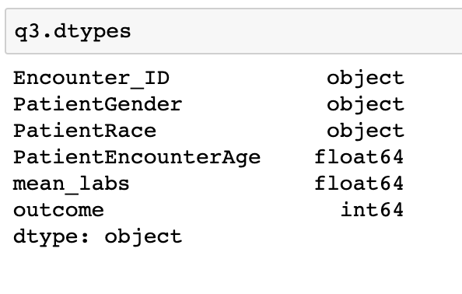

What the dataset looks like:

The table for Q3) is 36143 rows ✖️ 6 columns.

Q4) Split the data longitudinally in training (years <= 2004) and testing (years > 2004). Fill out table below using both count and % in bracket. Percentages are to be calculated within each column with “Total” as the denominator. Basically, you want to make sure that the outcome rate is comparable between the training and the test dataset.

|  |  |  |
| --- | --- | --- |
|  | Training (<= 2004) | Test (> 2004) |
| Patients who were re-admitted within 30 days | 78 (0.36%) | 50 (0.34%) |
| Patients who were not re-admitted within 30 days | 21,416 (99.64%) | 14,599 (99.66%) |
| Total | 21,494 (100.00%) | 14,649 (100.00%) |

**Section 2: GUSTO 30-day Mortality Prediction**

Q1) Using the datasets provided for the GUSTO study, fill out the following Table 1.

Ans.

|  |  |  |  |  |
| --- | --- | --- | --- | --- |
|  | | Patients who died within 30 days (n=231) | Patients who were alive at 30 days  (n= 3,430) | *P-value* |
| Age, years, mean (sd) | | 71.08 (10.72) | 60.16 (11.56) | 3.5536*10^-43  < 0.001 |
| Gender | Male, n (%) | 140 (60.61%) | 2,581 (75.25%) | < 0.001 |
|  | Female, n (%) | 91 (39.39%) | 849 (24.75%) |
| Group | sample2, n (%) | 20 (8.66%) | 239 (6.97%) | 0.694 |
|  | sample4, n (%) | 52 (22.51%) | 733 (21.37%) |
|  | sample5, n (%) | 24 (10.39%) | 405 (11.81%) |
|  | west, n (%) | 135 (58.44%) | 2,053 (59.85) |

Q2) Split the dataset into training (groups = sample2 or sample4 or sample5) and testing (group = west). Fill out table below using both count and % in bracket. As before, use “Total” as the denominator in order to ensure that the outcome rate between training and test is consistent.

Ans.

|  |  |  |
| --- | --- | --- |
|  | Training | Test |
| Patients who died within 30 days | 96 (6.52%) | 135 (6.17%) |
| Patients who were alive at 30 days | 1,377 (93.48%) | 2,053 (93.83%) |
| Total | 1,473 (100.00%) | 2,188 (100.00%) |

Q3) Insert a summary of the train data and test data. Ensure all variables are properly represented as either numeric or categorical. Use the data dictionary as your guide to format the features. Save your workspaces for future use.

Ans.

I combined the two training sets of “Patients who died within 30 days” and “Patients who were alive at 30 days” as a complete training set. Then I combined the two test sets of “Patients who died within 30 days” and “Patients who were alive at 30 days” as a complete test set. Finally, I used dataframe.describe() as the summary() in Python to make an overview of the dataset.

Training set summary (Total 1,473 rows of data):

The training set’s data types:

Test set summary (Total 2,188 rows of data):

The test set’s data types:

(Training and testing datasets have been saved into my computer)